Computing, Year 2
Web Applications
Lab sheet 3
Exercise 1 – Pizza Form – pizzaForm.html
Create a form (pizzaForm.html) for ordering pizza from ApachePizza.
Your form should have the following:

Fieldsets and Legends
Radio buttons or Dropdown Menu
- Type of crust (thin, thick,rye )
- Thick is checked
Checkboxes
- Toppings (extra cheese, pepperoni, mushrooms)
- Note: extra cheese is checked
Textboxes
- Username
- Password (check that it displays ******) – Put the word optional beside it (in red)
Textarea
- A text area for comments and special instructions
Submit button
- - ‘Order Now’
Reset Button

Notes
- Save your form as pizzaForm.html.
- Form data should be sent to pizzaForm.php
- Create an external CSS sheet and do the following
- Change the background colour of the form, give it a coloured border
  - ie. border: 1px solid red;
- Put a coloured border around the fieldsets
- Centre the buttons i.e. margin-left: 20%;
- Centre the textarea.
- Put h1 in red, and “optional” in red

The form should display, as follows:

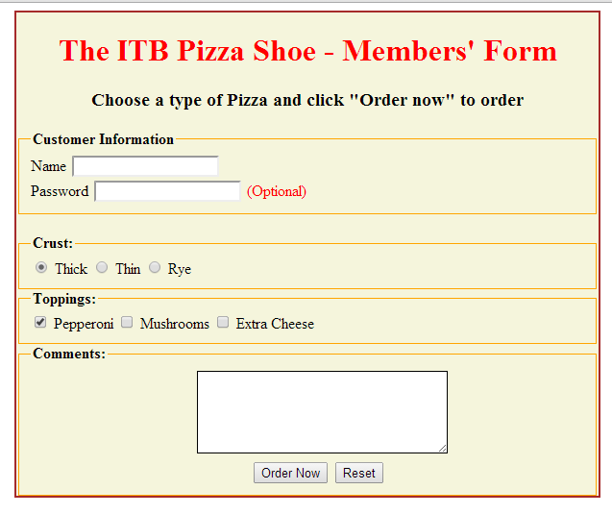

Exercise 2 – pizzaForm.php

Create a php program (pizzaForm.php) that processes the details from the HTML form (pizzaForm.html) and displays the output. [Remember to call this program (pizzaForm.php) from your html program]

- Validate that the fields you are displaying are not blank.
- Your program should display, as follows: (Choose any image).

